Chinwendu Imegwu

11/1/2024

Week 3 assignment

Lab Prerequisites:

- A Linux environment (Ubuntu 22.04 LTS, Linux Mint 21.3 LTS, Ubuntu Server, CentOS Server).

- Git installed (`sudo apt install git` or `sudo yum install git`).

- SSH access to a remote Linux system for practicing remote backups.

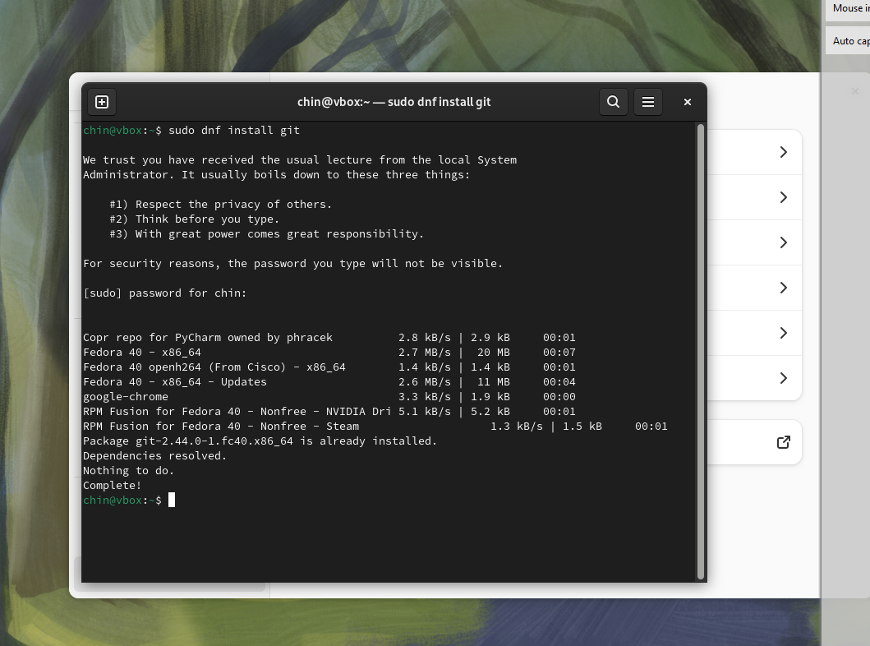

Part 1: Logging Into Local and Remote Consoles

Task 1.1: Logging into a Local Text Mode Console (CLI Mode)

1. Switch to a text-based console by pressing `Ctrl + Alt + F1` (or F2-F6 for additional consoles).

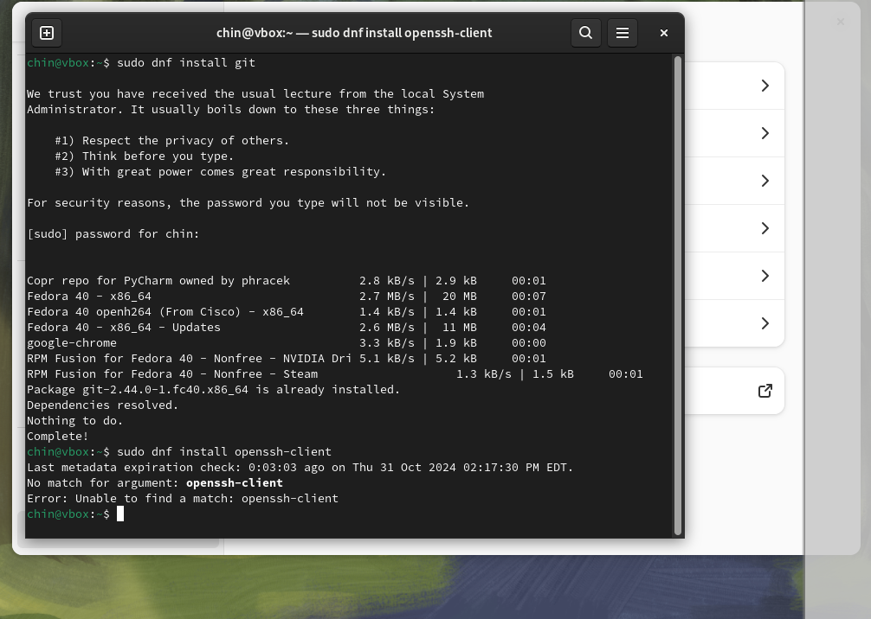

. Install the SSH client (if not already installed):

- Ubuntu/Mint:

```bash

sudo apt install openssh-client

```

- CentOS:

```bash

sudo yum install openssh-clients

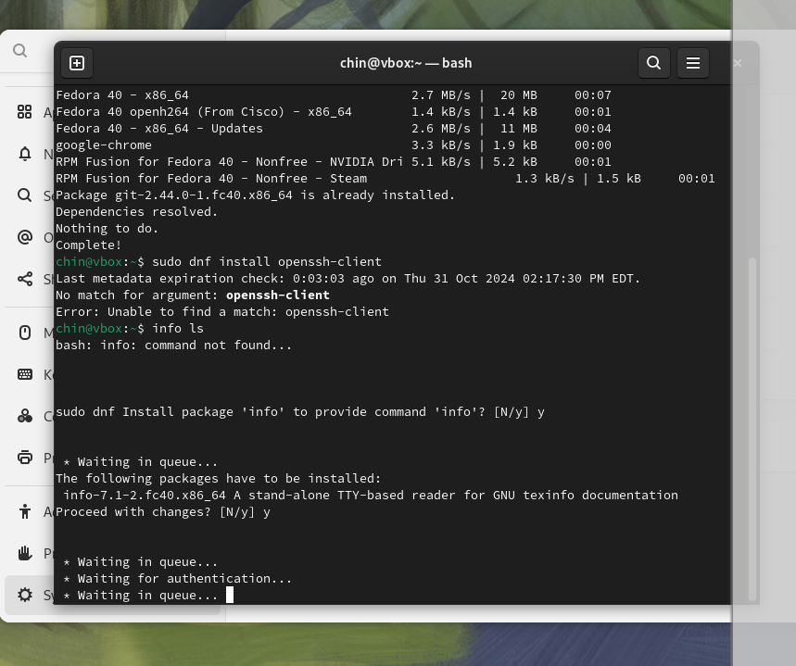

Final result:

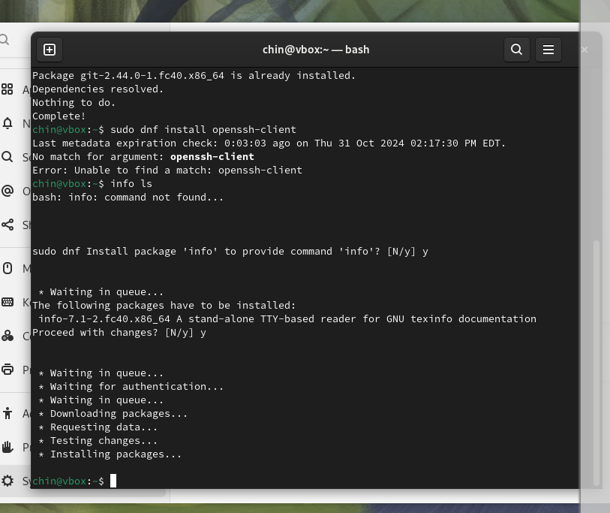

- CentOS:

```bash

sudo yum install openssh-clients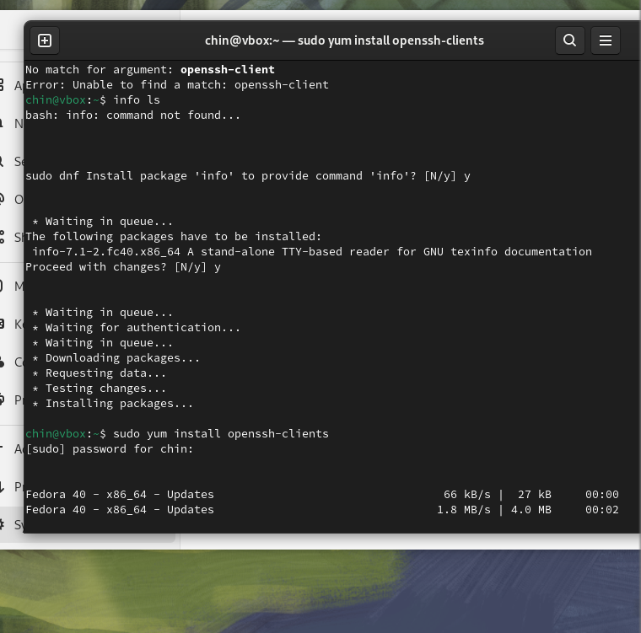

Final result:

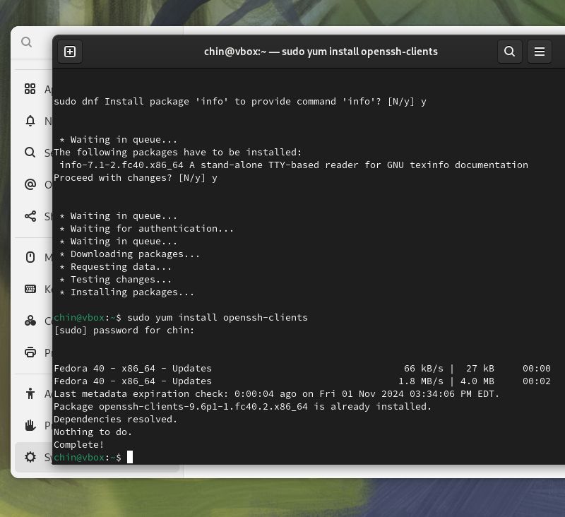

Connect to a remote server:

```bash

ssh user@remote_ip

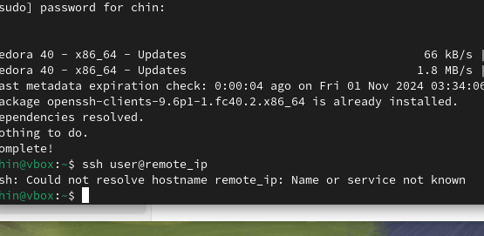

Part 3: File and Directory Management

Task 3.1: Creating, Deleting, Copying, and Moving Files and Directories

1. Create a new directory:

```bash

mkdir /tmp/mydir

```

2. Create a new file:

```bash

touch /tmp/mydir/myfile.txt

```

3. Copy the file:

```bash

cp /tmp/mydir/myfile.txt /tmp/myfile_copy.txt

```

4. Move the file:

```bash

mv /tmp/myfile_copy.txt /tmp/movedfile.txt

```

5. Delete the file and directory:

```bash

rm /tmp/movedfile.txt

rm -r /tmp/mydir

```

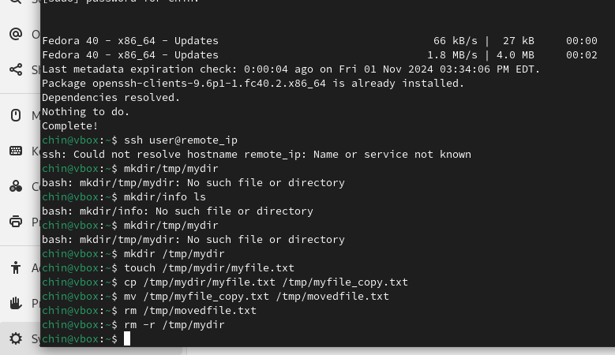

Part 4: Creating and Managing Hard Links and Soft Links

Task 4.1: Create and Manage Hard Links

1. Create a hard link:

```bash

ln /tmp/myfile.txt /tmp/hardlink.txt

```

2. Verify the link using `ls -li` (this shows the inode numbers, which should be the same for the original and hard link):

```bash

ls -li /tmp/myfile.txt /tmp/hardlink.txt

```

Task 4.2: Create and Manage Soft (Symbolic) Links

1. Create a soft link:

```bash

ln -s /tmp/myfile.txt /tmp/softlink.txt

```

2. Verify the link:

```bash

ls -l /tmp/softlink.txt

```

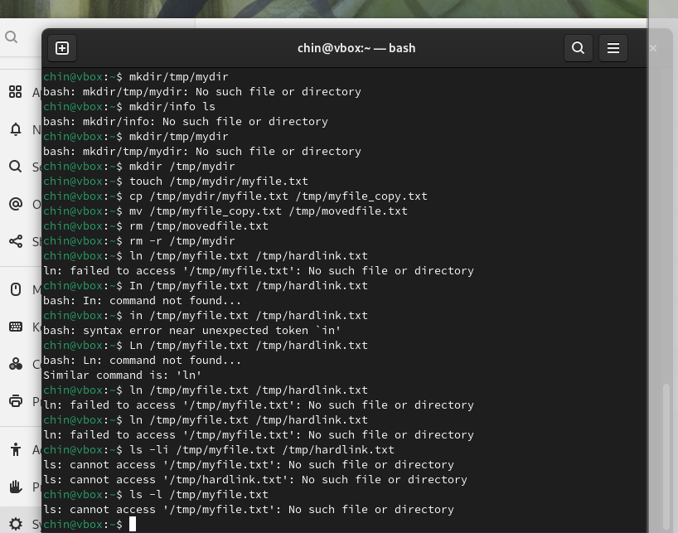

Part 7: Archiving and Compressing Files

Task 7.1: Archive, Compress, and Uncompress Files

1. Create a tar archive:

```bash

tar -cvf /tmp/myarchive.tar /tmp/myfile.txt

```

2. Compress the archive:

```bash

gzip /tmp/myarchive.tar

```

3. Uncompress and extract the archive:

```bash

gunzip /tmp/myarchive.tar.gz

tar -xvf /tmp/myarchive.tar

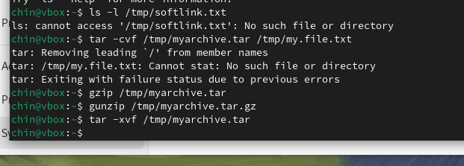

Part 8: Backup Files to a Remote System

Task 8.1: Backing Up Files Using SCP or RSYNC

1. Use SCP to copy files to a remote system:

```bash

scp /tmp/myfile.txt user@remote_ip:/home/user/

```

2. Use RSYNC for efficient file synchronization:

```bash

rsync -avz /tmp/mydir/ user@remote_ip:/home/user/backup/

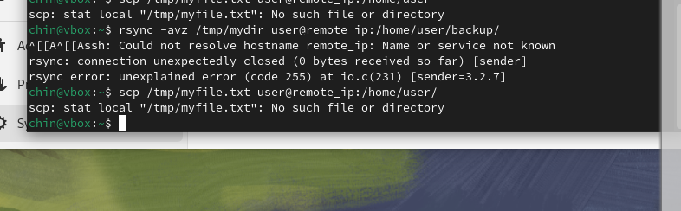

1. Redirect the output of a command to a file:

```bash

ls -l /tmp > /tmp/output.txt

```

2. Use input redirection to provide input to a command from a file:

```bash

cat < /tmp/output.txt

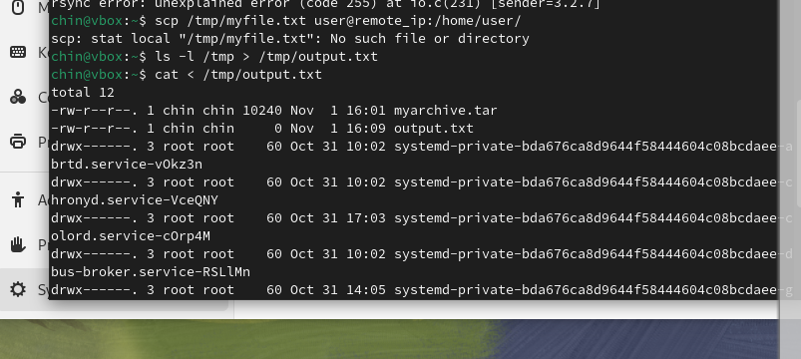

Part 10: Working with SSL Certificates

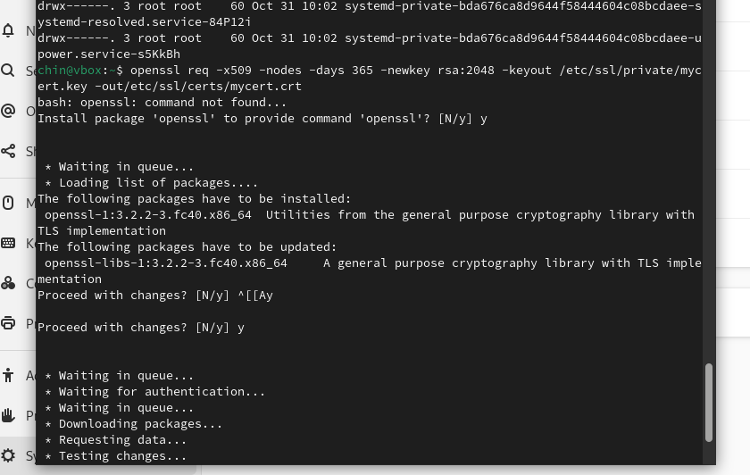

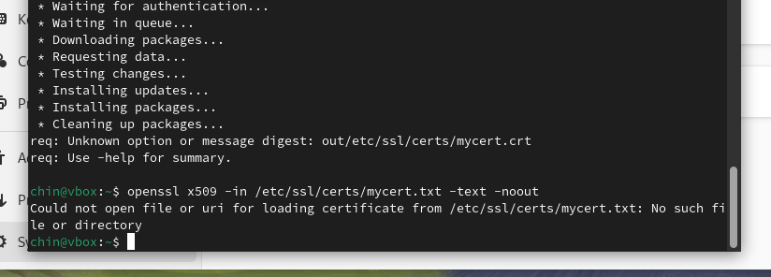

Part 11: Git Basics

Task 11.1: Git Setup and Configuration

1. Initialize a Git repository:

```bash

git init /tmp/myrepo

```

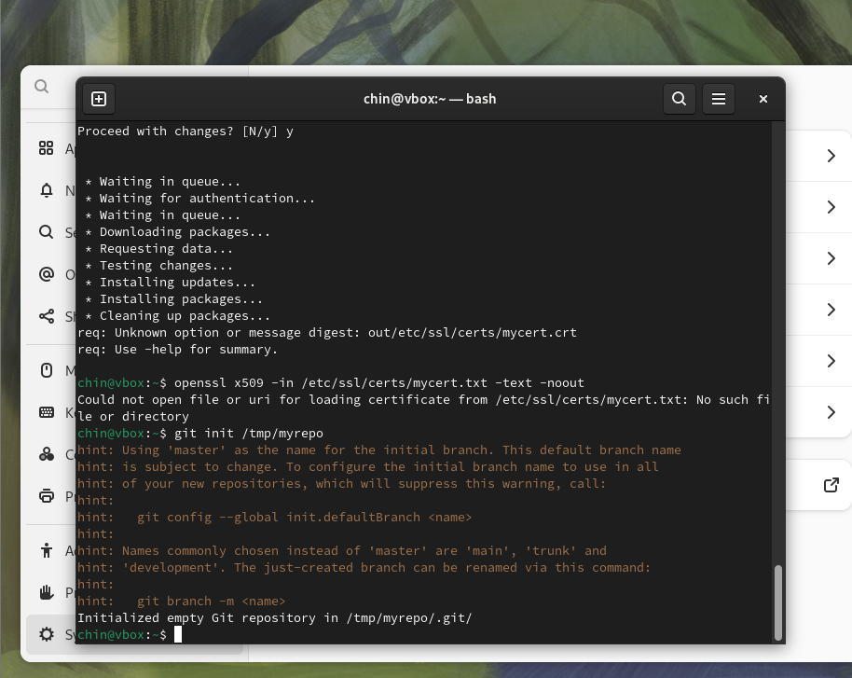

2. Configure your Git username and email:

```bash

git config --global user.name "Your Name"

git config --global user.email "[youremail@example.com](mailto:youremail@example.com)"

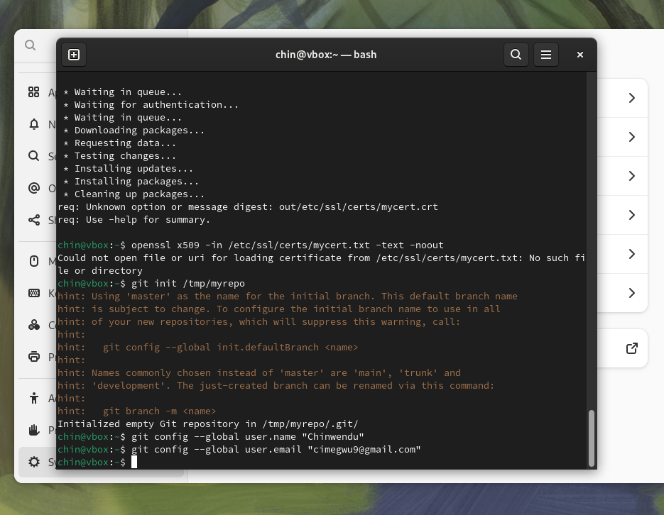

Task 11.2: Staging and Committing Changes

1. Add a file to the staging area:

```bash

git add /tmp/myfile.txt

```

2. Commit the changes:

```bash

git commit -m "Initial commit"

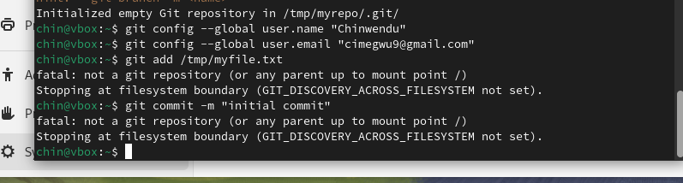

Task 11.3: Working with Branches and Remote Repositories

1. Create a new branch:

```bash

git checkout -b new-feature

```

2. Push the branch to a remote repository:

```bash

git remote add origin <https://github.com/username/repo.git>

git push -u origin new-feature

```